**You're No Good (Clint Balard) Key A**

**Intro: Am D Am D Am D Am D**

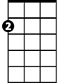

Am

F



G

E7

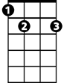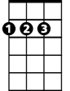

D

**Am D Am D**

Feeling better now that we're through

**Am D Am D**

Feeling better 'cause I'm over you

**F G C**

I learned my lesson, it left a scar

**Am D E7**



C

Now I see how you really are

**Chorus:**

**Am D Am D Am D**

You're no good, You're no good You're no good Baby you're no good

**Am D**

I'm gonna say it again

**Am D Am D Am D Am D**

You're no good You're no good You're no good Baby you're no good

**BARITONE**

**Am D Am D**



D

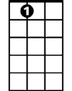

E7



F

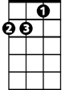

Am



G

I broke a heart that's gentle and true

**Am D Am D**

Well I broke a heart over someone like you

**F G C**

I'll beg his forgiveness on bended knee

**Am D E7**

I wouldn't blame him if he said to me

C



**(Chorus)**

**Am D Am D**

I'm telling you now baby and I'm going my way

**Am D Am D**

Forget about you baby 'cause I'm leaving to stay

**Am D Am D Am D**

You're no good, you're no good, you're no good - Baby you're no good

**Am D**

I'm gonna say it again

**Am D Am D Am D Am D**

You're no good, you're no good, you're no good - Baby you're no good **-** Oh, no

**(TACET slowly)**

You're no good, you're no good, you're no good - Baby you're no go-oo-od

**(Am C D) x4**

**You're No Good (Clint Ballard) Key D**



Bb



G



Dm



A7



C

**Intro: Dm G Dm G Dm G Dm G**

**Dm G Dm G**

Feeling better now that we're through

**Dm G Dm G**

Feeling better 'cause I'm over you

**Bb C F**

I learned my lesson, it left a scar

F



**Dm G A7**

Now I see how you really are

**Chorus:**

**Dm G Dm G Dm G**

You're no good, You're no good You're no good Baby you're no good

**Am D**

I'm gonna say it again

**Dm G Dm G Dm G Dm G**

You're no good You're no good You're no good Baby you're no good

**BARITONE**

**Dm G Dm G**

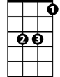

Bb

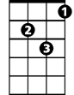

Dm



G

I broke a heart that's gentle and true

**Dm G Dm G**

Well I broke a heart over someone like you

**Bb C F**

I'll beg his forgiveness on bended knee

**Dm G A7**

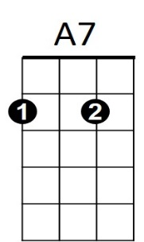I wouldn't blame him if he said to me



F

C



**(Chorus)**

**Dm G Dm G**

I'm telling you now baby and I'm going my way

**Dm G Dm G**

Forget about you baby 'cause I'm leaving to stay

**Dm G Dm G Dm G**

You're no good, You're no good You're no good Baby you're no good

**Am D**

I'm gonna say it again

**Dm G Dm G Dm G Dm G**

You're no good You're no good You're no good Baby you're no goodOh, no

**(TACET Slowly)**

-=You're no good You're no good You're no good Baby you're no go-oo-od

**(Dm F G) x4**