Stormy Weather (Harold Arlen, Ted Koehler) (C)

Intro: C Am Dm7 G7  C Gm6 Dm G7  Don't know why there's no sun up in the sky  C Am7  Stormy weather  Dm7 G7 C Am  Since my gal and I ain't to-gether,  Dm7 G7 C Am Dm7 G7  Keeps rainin' all the time  C Gm6 Dm G7  Life is bare, gloom and misery every-where  C Am7  Stormy weather  Dm7 G7 C Am  Just can't get my poor self to--gether,  Dm G7 C Am Dm7 G7  I'm weary all the time  G7 C Am Dm7 G7  So weary all the time  Dm G7 C Am  When she went away the blues walked in and met me.  Dm G7 C Am  If she stays away old rockin' chair will get me.  Dm G7 C A7  All I do is pray the Lord above will let me,  D7 G7  Walk in the sun once more.  C Gm6 Dm G7  Can't go on, every thing I had is gone  C Am7  Stormy weather  Dm7 G7 C Am  Since my gal and I ain't to-gether,  Dm G7 C Am Dm7 G7  Keeps rainin' all the ime  Dm G7 C Am Dm7 G7 C  Keeps rainin' all the time |  |  | 
 |  |  | 
 | 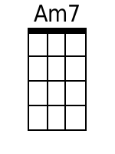 | 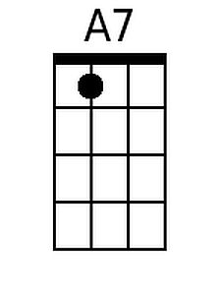 | 
 |  | Bari
 |  |  | 
 |  | 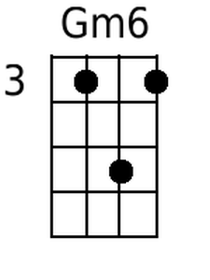 | 
 |  |  | 

