Scooby Doo Theme (Ted Nichols, Hoyt Curtin, David Mook, Ben Raleigh) (C)
Scooby Doo Theme by Larry Marks, George A Robertson Jr

C Dm  Scooby-Dooby-Doo, where are you?  G C  We've got some work to do now  C Dm  Scooby-Dooby-Doo, where are you?  G C  We need some help from you now  C Dm  Come on, Scooby Doo, I see you  G C  Pre-tending you got a sliver  C Dm  But you're not fooling me cause I can see  G C  The way you shake and shiver...  F  You know we got a mystery to solve  C  So, Scooby Doo, be ready for your act!  Bb C F  Don't hold back! And Scooby Doo, if you come through  G  You'll have yourself a Scooby snack. That's a fact!  C Dm  Scooby-Dooby-Doo, here are you.  G C  You're ready and you're willing.  C Dm  If we can count on you, Scooby Doo,  G C  I know you'll catch that villain. |  |  |  |  |  |  | 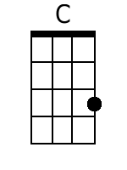
 |  |  |  |  |  |  | 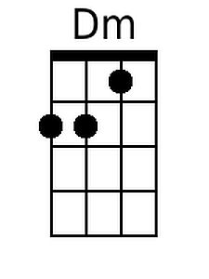
 |  |  |  |  |  |  | 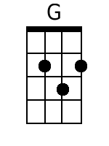
 |  |  |  |  |  |  | 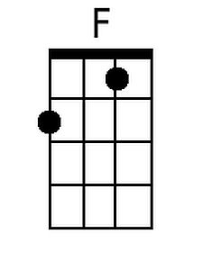
 |  |  |  |  |  |  | 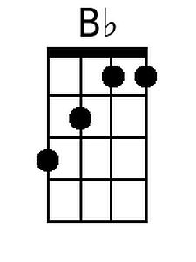
Baritone
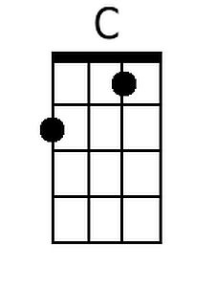 | 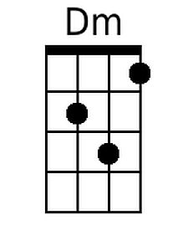 | 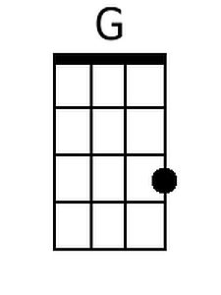 | 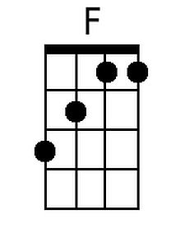 | 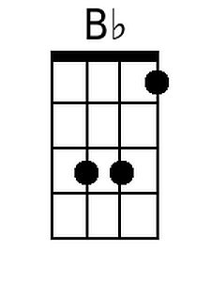

Scooby Doo Theme (Ted Nichols, Hoyt Curtin, David Mook, Ben Raleigh) (G)
Scooby Doo Theme by Larry Marks, George A Robertson Jr

G Am
Scooby-Dooby-Doo, where are you?
D G
We've got some work to do now
G Am
Scooby-Dooby-Doo, where are you?
D G
We need some help from you now

G Am
Come on, Scooby Doo, I see you
D G
Pre-tending you got a sliver
G Am
But you're not fooling me cause I can see
D G
The way you shake and shiver...

C
You know we got a mystery to solve
G
So, Scooby Doo, be ready for your act!
F G C
Don't hold back! And Scooby Doo, if you come through
D
You'll have yourself a Scooby snack. That's a fact!

G Am
Scooby-Dooby-Doo, here are you.
D G
You're ready and you're willing.
G Am
If we can count on you, Scooby Doo,
D G
I know you'll catch that villain.

 |  |  |  |  |  |  | 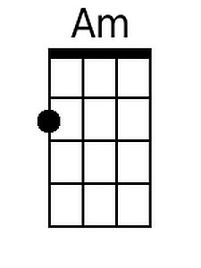
 |  |  |  |  |  |  | 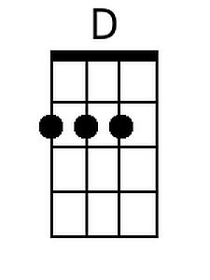
Baritone
 | 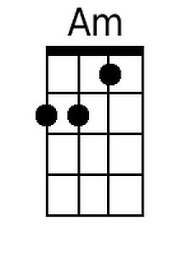 | 