Cryin' in the Rain (Howard Greenfield / Carole King) (G)

G C D7 G  I'll never let you see  C D7 G  The way my broken heart is hurting me  C B7 Em  I've got my pride and I know how to hide  C D7  All my sorrow and pain  Em D7 Em  I'll do my crying in the rain  G C D7 G  If I wait for cloudy skies  C D7 G  You won't know the rain from the tears in my eyes  C B7 Em  You'll never know that I still love you so  C D7  Only heartaches remain  Em D7 G  I'll do my crying in the rain  C Am  Rain drops falling from heaven  D7 G  Could never wash away my misery  Am  But since we're not together  C  I look for stormy weather  D7  To hide these tears I hope you'll never see  G C D7 G  Some day when my crying is done  C D7 G  I'm gonna wear a smile and walk in the sun  C B7 Em  I may be a fool but till then darling, you'll  C D7  Never see me complain  Em  I'll do my crying in the rain  D7 Em  I'll do my crying in the rain | 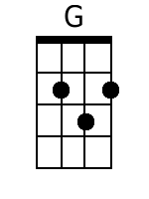 | 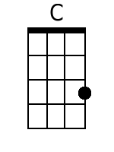 | 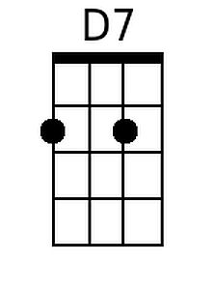
 | 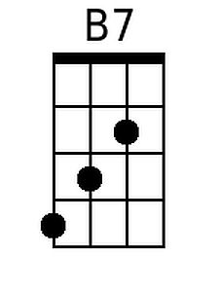 | 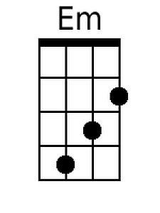 | 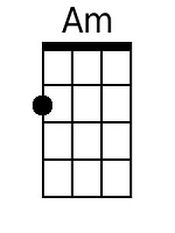
 | Bari
 | 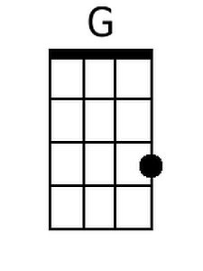 | 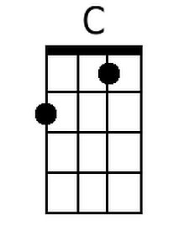 | 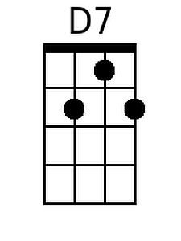
 | 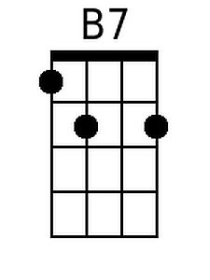 | 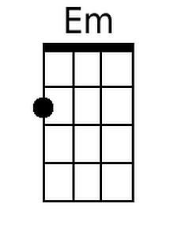 | 